INFORMAL / FORMAL LANGUAGE
- Use full verbs (no abbreviations)
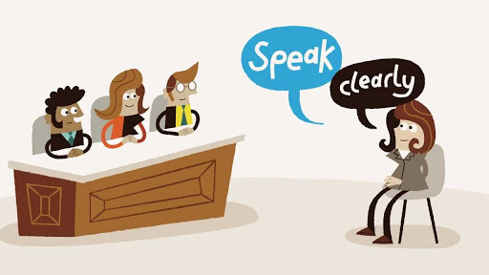
- Choose more formal words.
- Don’t be too straight. Use more polite phrases.
- Speak clearly and slowly.
- Ask questions (Could you please…?)

Informal Phrases | Formal phrases
Hello!
How are you?
I’m Véronique and I work here.
We are here because…
I’m worried about..
We want to talk to you about…
First,
Also,
But
I think
Sorry but…
Tell us about…
Explain why…
I can’t change…
I need to get…
It’s because…
I know about ….
That’s false! You’re wrong!
I want to ask for…
How much is…?
You need to change your mind!
Informal phrases | Formal phrases
Answers:
Informal Phrases | Formal phrases
Hello! | Good morning!
How are you? | Pleased to meet you.
I’m … | Let me introduce myself. My name is…
We are here because… | The reason why we are here today is because…
I’m worried about.. | I am extremely concerned about…
We want to talk to you about… | We would like to discuss…
First, | Firstly,… The first issue is…
Also, | In addition,….  I would like to add..  Secondly,…
but | However,…  On the other hand,…  In spite of this,…
I think | I believe  In my opinion  From my point of view
Sorry but… | I am sorry to interrupt but…
Tell us about… | Could you please inform us about……?
Explain why… | Would you mind explaining the reason for…..?
I can’t change… | I am unable to change…
I need to get… | It is important for me to get…  It is necessary for me to get….
It’s because… | The reason why I say that is…
I know that …. | I am aware that….
That’s false! You’re wrong! | I am sorry to say I disagree with you on this point.  That is a good point but I disagree
I want to ask for… | I would like to request…
How much is…? | What is the cost of…?
You need to change your mind! | Could you please reconsider your decision?

